**HEALTHCARE SAAS STARTUP FOR**

**AI SERVICE BUSINESS & FINANCIAL MODELLING**

A PROJECT REPORT

SUBMITTED TO

FEYNN LABS

BY

SAURABH BHADALE

BHARGAV KANTHETI

KUMAR SAMBHAV

JULY 2022

**INTRODUCTION**

Healthcare Software-as-a-Service (SaaS) applications initially faced a lot of backlashes due to security reasons. Today, with more safeguards in place, healthcare businesses are starting to see the benefits.

Many healthcare organizations are turning to SaaS as a more affordable way of deploying cloud-based EHRs (electronic health records). They have begun deploying SaaS applications throughout their hospitals.

These apps include EMR (electronic medical records), EHR, PACS, telehealth, etc. Some nonclinical information systems include RCM, billing, supply chain, and more

 healthcare is a vital sector, and the pandemic has only highlighted its important role further.  With new technologies rolling out regularly, the future of the healthcare industry is anticipated to be bright. Technology equips healthcare facilities not only to raise efficiency levels but also to improve their care processes.

On-site solutions that healthcare facilities once used are now considered obsolete, replaced by cloud-based SaaS platforms. The increasing growth of SaaS benefits the medical sector in several ways.

In simple words, it is software designed for the healthcare sector that is licensed on a subscription basis.  When it was first introduced, it was known as software plus service, and despite the innovation, it brought to the healthcare sector, it was initially met with backlash.

Today, several medical facilities are benefitting from this healthcare software**.**This includes [clinical decision support systems,](https://digitalhealth.folio3.com/blog/clinical-decision-support-system-examples-tools/) EHRs, and [healthcare cmms software](https://digitalhealth.folio3.com/solutions/ecodocs/), [HIPAA compliant telemedicine software](https://digitalhealth.folio3.com/telemedicine-software-development-company/) and many more, which are now considered a highly trustworthy method of improving healthcare across organizations.

Most hospitals are now employing SaaS in every department to facilitate seamless operations in their healthcare services.

**MARKET OVERVIEW**

## India's SaaS market to be valued at $50 billion by 2030, says studyWith $4.8 billion in venture capital invested in the industry in 2021, nearly 3 times as much as in 2020, the SaaS market in India has already reached a critical turning point, noted a report by Bessemer Venture Partners.

India is predicted to emerge as a world leader in cloud computing within the next eight years, according to a report on the Software-as-a-Service (SaaS) industry in the country, which is anticipated to grow at an accelerated rate in the coming years.

According to projections made in the first edition of Bessemer Venture Partners’ India report titled ‘Rise of the Cloud in India’, the country is predicted to hugely benefit from the global shift of industries towards increased digitisation and cloud-based technologies, so much so that India’s SaaS industry is expected to touch the $50 billion mark by the end of 2030.

With $4.8 billion in venture capital invested there in 2021, nearly three times as much as in 2020, and a stunning six times as much as in 2018, the SaaS market in India has already reached a critical turning point. Increased investment for SaaS firms, similar to that given to U.S. venture-backed companies, has fuelled the emergence of new unicorns in the country, according to the report.

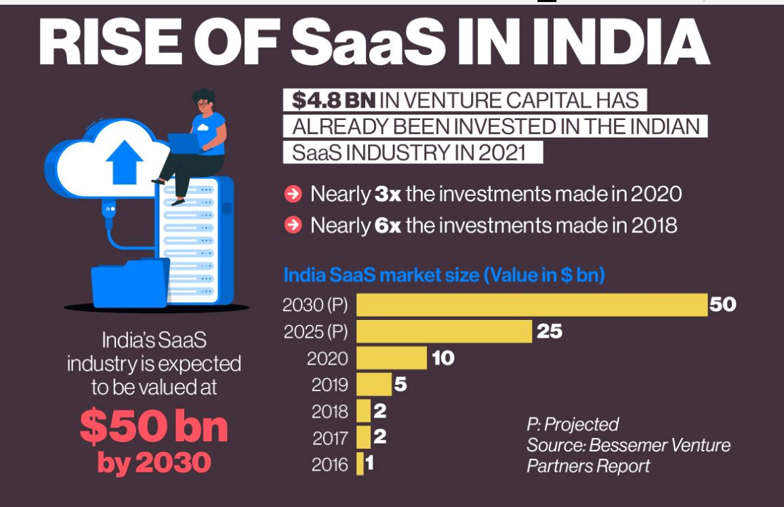

The rise is reportedly happening so quickly that in the past three and a half years, India has already gone from having just two SaaS unicorns to about 20. In the first four months of 2022, India alone contributed four new names to this list. The number of new unicorns in the Indian IT business increased by 267 per cent within just one year (2020-21)

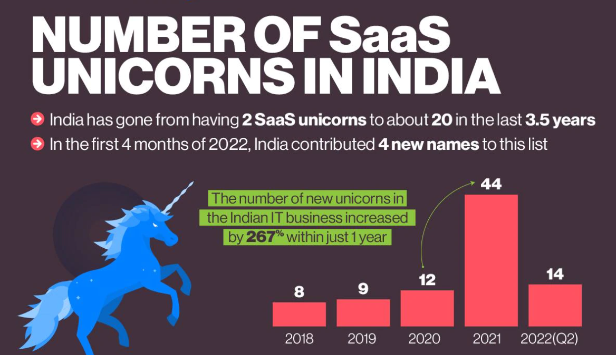

**US HEALTHCARE SAAS MARKET:**

The global healthcare software as a service market size was valued at USD 14.5 billion in 2022 and is expected to expand at a compound annual growth rate (CAGR) of 19.5% from 2021 to 2028. The growing adoption of cloud technologies and growing digitalization in healthcare are major parameters driving the growth of the healthcare Software as a Service (SaaS) market during the forecast period. According to the Right Scale report published in 2019, a software service company, 94% of the enterprises use the cloud. It also suggests that around 21% of enterprises are planning to install cloud in near future.

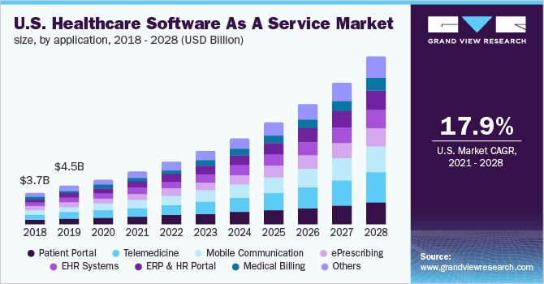

Healthcare companies are adopting SaaS for cost benefits, security, ease of use, ease of integration, customer support, enhanced administration and management capabilities, uptime guarantee, scalability, customizability, data center infrastructure, disaster recovery plan, and reporting. SaaS finds various applications, such as in website, email, communications, mobile services, [customer relationship management](https://www.grandviewresearch.com/industry-analysis/customer-relationship-management-crm-market), mobile services, productivity apps, ERP, data analytics, document management, and database server.

Digitalization is witnessing rapid growth in the healthcare sector. The COVID-19 pandemic has accelerated digitalization. Healthcare organizations faced multiple challenges such as the shortage of workforce and resources. Healthcare organizations started adopting digital platforms during the pandemic to overcome these challenges and to increase return on investment. According to a survey published by Innovaccer Inc., a health cloud company, in 2021, 49% of healthcare organizations were actively working toward digital transformation.

The goal of health organizations was to provide [telehealth](https://www.grandviewresearch.com/industry-analysis/telehealth-market-report) services for 39% of respondents, automation of care management for 30% of respondents, automation of care pathways and coordination step for 20% of respondents, and enhancement of triage and risk assessment capabilities for 11% of respondents. Moreover, improving clinical operation, modernizing data platforms, the integration of disparate systems, and rationalizing IT expenditures were the top priorities of organizations. Thus, increasing plans to install and upgrade advanced digital facilities are estimated to drive market growth.

Increasing adoption of telehealth, wearable devices, [mobile applications](https://www.grandviewresearch.com/industry-analysis/mobile-application-market), remote patient monitoring, ERP, CRM, and surging patient data are contributing to the growth. As per a report by the International Telecommunication Union, 12.1 billion people are estimated to have smartphones by 2030. As per an article published by the Journal of Medical Internet Research in 2020, 30% of adults from the U.S. regularly use wearable devices. As per a study published by the European Commission in 2017, 96% of the doctors from Europe use EHR. All these parameters are contributing to the adoption of SaaS.

**GLOBAL HEALTHCARE SAAS MARKET:**

In 2020, the hybrid segment held the highest revenue share of 50.2% in the global healthcare software as a service market. It is attributed to the high adoption of hybrid SaaS by all industries, including healthcare as it offers a combination of public and private cloud. The hybrid deployment model offers benefits, including flexibility to support a remote workforce, better security and data control at reduced costs, improved scalability, enhanced innovation, improved security, and easy risk management.

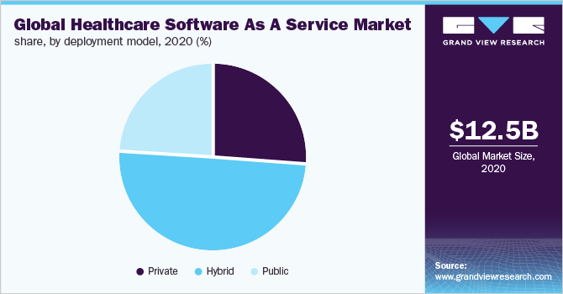

The public deployment model is estimated to witness lucrative growth during the forecast period. According to a study conducted by HIMMS in Germany, the majority of the hospitals in Germany use the public cloud. Public SaaS offers significant cost savings as they are managed by third-party vendors. Moreover, it is easy to maintain and upgrade. However, the public cloud may have speed, accessibility, and security issues cloud is shared.

**HEALTHCARE SAAS TRENDS:**

1) **Smart Artificial Intelligence (AI) Solutions:**

Artificial Intelligence (AI) is poised to dominate the market with its smart business applications. AI integration allows SaaS platforms to become self-learning and autonomous. AI-based solutions are popular among healthcare organizations.

Many successful technology companies are automating business processes via AI, thereby increasing productivity and efficiency. Experts highlight that [around 81%](http://www.woodsidecap.com/wp-content/uploads/2017/01/Artificial-Intelligence-Report.pdf) of the companies are already working on AI technologies.

The impact of AI through natural language processing (NLP) and [machine learning](https://www.imaginovation.net/blog/artificial-intelligence-vs-machine-learning/) (ML) is transforming care delivery.

ML uses algorithms to parse data and detect patterns. It can process large amounts of data, learn from it, and make predictions. It allows systems to act according to the situation, without being explicitly programmed to do a specific set of actions.

On the other hand, the pattern recognition feature allows companies to set their machines to a pre-set goal. The system can notify the admins when something happens.

Healthcare SaaS businesses can benefit from AI automation in multiple ways. At first, it resolves the concerns around security breaches. The ability to recognize patterns makes detecting potential threats easier. The best part—there’s a self-recovery aspect that can help to recover critical data.

Next, the NLP facet can help to detect voice control and human speech patterns. Such software can help to address client needs and improve customization. Personalized pathways in healthcare are an exciting trend.

Another facet is ML, which companies often utilize in the customer service applications field. You can find the use of chatbots useful. Finally, the overall responsiveness levels and ability to have accurate predictions at immense speeds are possible with AI-enabled SaaS.

### **2. Use of Multiple Clouds**

Experts suggest the number of businesses using cloud-based apps to increase [by 19.6%](https://www.coolheadtech.com/blog/vanson-bournes-business-impact-of-the-cloud).

Healthcare companies can meet some of their most challenging issues with new SaaS trends. Many companies using Platform as a Service (PaaS) can enjoy distinct advantages in 2022 and beyond.

With multiple cloud providers, companies can increase their ability to store, process, analyse, and secure essential healthcare data. You may find tons of cloud providers being used for disaster recovery.

An exciting move was observed with APIs such as Google Health. It allowed companies to unlock healthcare data’s real value by leveraging big data differently.

You can expect to use Google’s multi-layered security approach, leveraging cutting-edge security capabilities, including data-loss prevention, identity management, encryption, and more.

### **3. Focused Attention to Security**

Data security is a major concern for healthcare providers across the world. With patient health records being digitized and placed on the cloud, there are concerns about cloud-based data breaches. It is critical to ensure a security model is in place that can track the traffic and data to and from the cloud.

Using a multi-cloud approach has its benefits. However, there are also chances of new security complexities.

You may find such complications getting more common as companies change from understanding Infrastructure as a Service (laaS) on a single cloud to understanding how PaaS and SaaS can work together.

The concerns around data security are genuine. Hence, companies will find an increasing need for cloud security in 2022 and beyond.

## STEPS TO BUILD A HEALTHCARE SAAS PLATFORM

we will elaborate on the steps needed to develop a healthcare SaaS platform for healthcare organizations and healthcare professionals

In this start-up we intended to build a healthcare SaaS platform that would deliver healthcare information services at a low cost. It will focus on high clinical value and usability.

The project scope included the following:

* Sharing of ’clinical decision service ‘(CDS) content services;
* Basic order entry system;
* Immunization management;
* Account management;
* Patient information management;
* Scheduling of appointments and admissions;
* Mobile services for multiple platforms;
* An EHR (electronic medical records) system that supports multiple device types.

The platform aimed to create a mobile-enabled cloud-based modular EHR system.

* Interface
* Business support services ([BSS](https://www.techopedia.com/definition/26873/business-support-system)) – a concept from the telco industry with usage in IT systems for other industries too;
* Operational support services ([OSS](https://searchtelecom.techtarget.com/definition/operational-support-system)) – like BSS, originally a concept from telco IT;
* Cloud component for SaaS;
* Quality attributes;
* Data security and privacy requirements;
* Multi-lingual services.

The platform must provide the following interfaces and frameworks:

* BSS;

**ESTIMATE THE COST TO BUILD A HEALTHCARE SAAS PLATFORM**

Cost estimation of a healthcare SaaS development project depends on a number of factors including:

* Targeted functionality;
* Cloud service provider and services involved;
* The location of the development team, i.e., the country they are based in.

Here is an estimate for developing an app with a few key functionalities.

We will need to factor in our requirements to get a more exact figure for your own project.  To do this you can consult each cloud service provider’s price charts for their IaaS and PaaS service rates.

* EMR/HER app Requires 4-6 weeks of work.
* Medical workflow automation: 3-4 weeks of development and testing.
* Medicare and Medicaid standards implementation: The most complex, time-consuming, and the most high-value projects, these can take 3-4 months.
* The social component allowing healthcare providers and patients to communicate requires heavy UI design, so estimate upwards of 2 months to complete this.
* Integration with medical devices: This requires a lot of customization due to the variety of devices as well as the wide range of integration that a healthcare organization may need. These projects take a minimum of 2 months.
* Medical mobile apps: Project development length varies quite considerably since there is a wide variety of apps – ranging from fitness apps to drug handbooks. A typical healthcare mobile app may take 4-6 weeks.
* Keep in mind that the above estimates were for individual apps. To deliver a healthcare SaaS, you need to have architects in your team to define your cloud architecture and integrate it with your existing systems.
* In addition to your normal IT team, you will also need infrastructure architects and cloud security experts. Their time requirement for the project will vary greatly based on the functionality, or the combination of functionalities, included in the project scope, etc.

**PROTOTYPE DEVELOPMENT:**

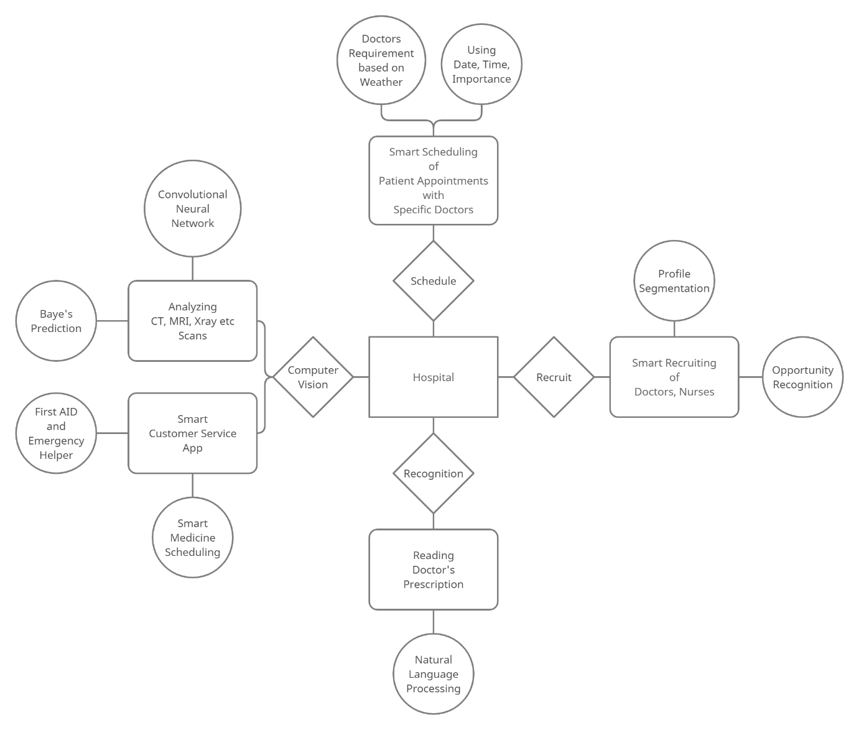

**BUSINESS MODELLING**

The solution is to embrace emerging technologies such as SaaS or Software-as-a-Service.

Now, in the healthcare sector, one of the [major concerns](https://www.ncbi.nlm.nih.gov/books/NBK234309/) with implementing new technologies is the cost.

That’s where the SaaS model in healthcare can fit in. Developing SaaS applications can be less expensive than developing standalone software.

SaaS platforms can deliver healthcare services faster, better, and cheaper. It’s time healthcare providers should focus on SaaS development and enhance productivity and [boost ROI](https://www.imaginovation.net/blog/driving-roi-with-voice-technology-healthcare/).

Artificial Intelligence (AI) is poised to dominate the market with its smart business applications. AI integration allows SaaS platforms to become self-learning and autonomous. AI-based solutions are popular among healthcare organizations.

Many successful technology companies are automating business processes via AI, thereby increasing productivity and efficiency. Experts highlight that [around 81%](http://www.woodsidecap.com/wp-content/uploads/2017/01/Artificial-Intelligence-Report.pdf) of the companies are already working on AI technologies.

The impact of AI through natural language processing (NLP) and [machine learning](https://www.imaginovation.net/blog/artificial-intelligence-vs-machine-learning/) (ML) is transforming care delivery.

ML uses algorithms to parse data and detect patterns. It can process large amounts of data, learn from it, and make predictions. It allows systems to act according to the situation, without being explicitly programmed to do a specific set of actions.

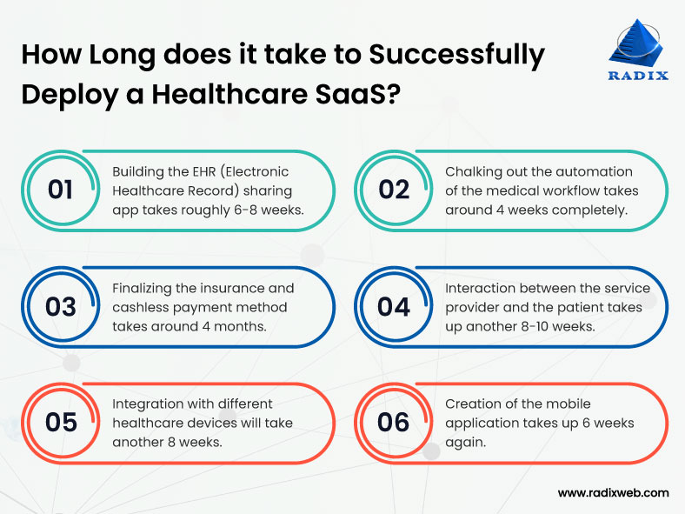

For this service, it is beneficial to use a Subscription Based Model**,** where initially some features will

be provided for free to engage customer retention and increase our customer count. Later it will be charged a subscription fee to use the service further for their business. In the subscription business model, customers pay a fixed amount of money on fixed time intervals to get access to the product or service provided by the company. The major problem is user conversion: how to convert the users into paid users.



The five top benefits we have identified for health providers of moving from a license model to a subscription model are:

* Continuously gain access to new technology and a broader set of functionalities
* Operational expense-based pricing is predictable, and immediately links cost to system utilization and healthcare revenue generation
* Scalability, both upwards and downwards
* Enables expansion to other imaging disciplines and departments without having to buy new licenses
* Facilitates mutually beneficial long-term partnerships with vendors

Switching from software license acquisition to a subscription service changes the model from ownership to access. When technology is moving fast and the demands on health providers are growing, the benefits of access to more functionality are becoming increasingly valuable: “Why own something that will be outdated in just a few months?”. In most cases, buying software as a subscription means you also gain access to a broader set of functionalities, which enables healthcare professionals to earlier adopt new methods in diagnosis and treatments.

The subscription model offers more predictable recurring payments and easier budgeting. A sliding scale pricing model is beneficial when volumes are unpredictable since costs are adjusted directly to the utilization of the system.

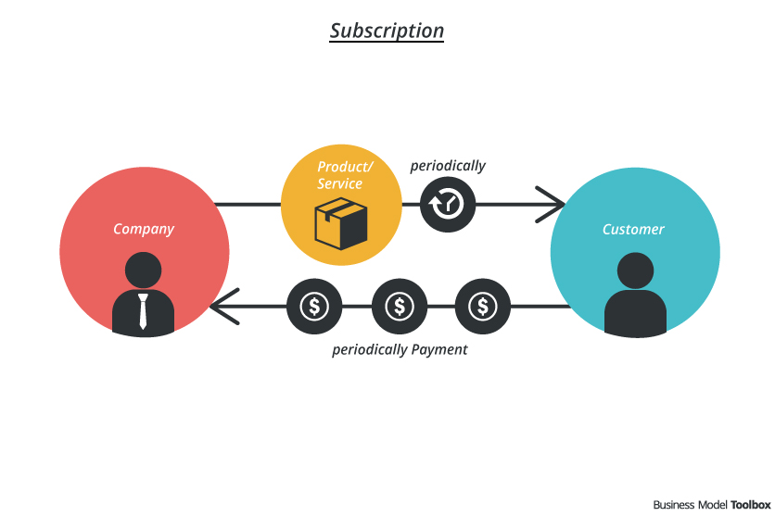

**Managing recurring transactional events in healthcare business processes:**

Healthcare transactional events involve capturing the patient information, related healthcare insurance provider, healthcare professionals and the provisioning of services and products. Let’s zoom into the recurring events:

1. The patient requires periodic delivery of products based on a prescription, healthcare plan or therapy, covered by a subscription plan;
2. Healthcare providers offer subscription plans to their patients, such as insurance plans, concierge services or treatment plans.

Automating the process of providing a recurring prescription need to pass though several events in the eco-system. There are three main components to the transactions:

1. Capturing the prescription and related subscription: **diagnose-to-prescribe**;
2. Processing the (periodic) payment events: **prescription-to-pay**;
3. Processing the continues provisioning of services and goods: **deliver-and-receive**.

**FINANCIAL MODELLING:**

### **THE KEY METRICS TO INCLUDE IN A SAAS FINANCIAL MODEL**

When determining financials for a SaaS start-up, understanding common metrics can help entrepreneurs create several documents, such as a business plan, financial forecast, financial plan, and beyond. A strong understanding of how figures are calculated can play a crucial role in determining financial benchmarks like early-stage operations, cash flow, and financial projections.

Below is a quick overview of some of the most common metrics and how they’re calculated.

#### **Average Revenue per User (ARPU)**

As one of the SaaS metrics, or key performance indicators (KPIs), commonly used by SaaS companies, ARPU helps the company look at the pricing and revenue per customer. This helps determine whether the customer is providing a business with a worthwhile profit.

It’s calculated by dividing the total revenue by the average number of customers over a chosen time period. This is different from looking at figures for a specific customer, which is more commonly used in sales and marketing to determine whether to continue pursuing a reluctant prospect or let the opportunity pass.

For example, if a company had $100,000 in revenue and 500 customers, the average revenue per user would be $200:

**$100,000 revenue / 500 customers = $200 ARPU**

#### **Churn Rate**

It’s important to keep track of your organization’s churn rate because it impacts customer lifetime value, monthly recurring revenue, revenue growth, and similar metrics. There are two ways to look at churn: gross and net.

Gross churn rate is the rate at which customers stop doing business with a company or unsubscribe from their service. As you lose customers, you have to allocate more significant resources to bring in more customers to replace those you lost. This increases your expenses *and* lowers your profits. Gross churn rate typically offers a better understanding of how many subscriptions were up for renewal over a given time period and how many of those actually renewed.

You can calculate your gross churn rate by dividing the number of customers who leave your company by your total number of customers.

For example, if you have 200 customers and 10 customers leave, you would have a churn rate of 5%:

**10 former customers / 200 total customers = .05, or 5% churn rate**

Net churn focuses on revenue and is calculated by taking the total dollar amount up for renewal over a given period and dividing that by the total dollar amount renewed. Ideally, this number should be greater than 100%, which indicates that your business is healthy and growing versus merely maintaining — or losing — revenue.

For example, say that a business has $5,000 up for renewal during a one-month period. They expanded their business through upgrades and cross-sold by $3,000 but lost $2,000 due to churn and downgrades. Here’s what the calculation would look like:

**$5,000 recurring revenue + $3,000 upgrades – $2,000 downgrades and churn / $5,000 = 1.2, or 120% net churn**

It’s important to track both gross churn and net churn because they reflect two very different numbers. Net churn can often look strong, but tracking gross churn as well will help give you a more accurate picture of your organization’s growth.

#### **Customer Acquisition Cost (CAC)**

Customer acquisition cost is the total cost of acquiring a customer an important figure that impacts your ideal conversion rate, pricing models, and [revenue forecast](https://www.salesassembly.com/revenue-forecasting-methods-b2b-saas/). It’s worth noting that CAC can vary greatly depending on the customers you’re targeting, as the sales and marketing spend in some industry verticals is much higher than in others.

If you have a low churn rate, spending more money on customer acquisition might make sense, but if the churn rate is high, it doesn’t make fiscal sense to spend a lot of money on acquiring new customers. Calculate CAC by dividing sales and marketing expenses by the total number of new customers in a business over a set period of time.

For example, if you spend $1,000 on sales and marketing to acquire 50 new customers in a month, your CAC is $20 per customer:

**$1,000 S&M budget / 50 new customers = $20 CAC**

#### **LTV: CAC Ratio**

Lifetime Value (LTV) is the total revenue each customer brings to your company. By comparing the LTV to the cost of acquiring that customer (Customer Acquisition Cost, or CAC), you can determine if you’re making or losing money on that client.

This is one of the reasons why reducing churn rate is so important, because having a high churn rate means that you’re quickly losing the money that you spent acquiring that customer. Calculate LTV:CAC ratio by first finding the value of LTV and CAC separately, then dividing LTV by the CAC.

Let’s say that a customer has created $50,000 in revenue for the company. That customer cost the company $10,000 to acquire. The LTV:CAC ratio for this customer is 5 to 1 (5:1):

**$50,000 LTV / $10,000 CAC = 5:1 LTV:CAC ratio**

While technically anything greater than 1:1 is profitable, 3:1 is considered healthy or preferable.

#### **Payback Period**

Payback period is the amount of time it will take to [repay an initial investment](https://courses.lumenlearning.com/boundless-finance/chapter/the-payback-method/). Depending on the profit margin on your services, the payback period could be weeks, months, or years.  You can calculate the payback period by dividing your initial investment to acquire the customer by your monthly cash flow. The resulting number is your payback period expressed in a number of years.

In the world of SaaS, this metric usually refers to the CAC payback period. For example, when a customer that had a CAC of $500 creates revenue for the company at or exceeding $500, the length of time it takes for this to happen is the payback period. If you receive a monthly revenue from a client of $50 per month, it would take 10 months to pay back the CAC from the LTV. This may also be referred to as a break-even point. Here’s how that looks:

**$500 initial investment / $50 per month revenue from client = 10 months to payback**

### **SaaS Financial Model Types**

Though these key metrics are very helpful in determining a number of factors for your company’s financials, your CFO may require more details in terms of your financial model. In some situations, they’ll use a financial model template to determine the valuation of the company.

This can be something as simple as an Excel template or a Google sheets document, to more sophisticated programs that provide greater functionality. This will depend on your company’s specific needs and the CFO’s experience with creating financial models.

#### **1. Operating Expense Model**

Your operating expense model takes a variety of information, such as cash flow statements, cost of goods sold (COGS), and similar financial data, and then condenses it into a single model. This provides you with a look at both forecasted and actual financials. By approaching operating expenses this way, you get a more solid look at your budget versus your actual spend, along with several other details that can help you make smarter business decisions.

#### **2. Forecasting Model**

Forecasting models are projections of where you anticipate your financials to be within a specific period of time. This type of SaaS model considers a number of future financials, such as payroll, business expenses, customer revenue, and cash flow projections.  Forecasts are not set in stone, but when done correctly, these models can provide you with a good idea of where your business is heading.

#### **3. Reporting Model**

Because SaaS companies often have unique KPIs that fall outside the usual three-statement structure (balance sheet, cash flow statement, and income statement), it can be beneficial to utilize a model that takes these unique metrics into account. Reporting models do exactly that, allowing for a range of assumptions to be tried, creating different forecasts that are specific to SaaS start-up concerns. The beauty in Reporting Models is that they are able to pull data from other models into a single, easily digestible format.

#### **4. Headcount Planning Model**

A [headcount planning model](https://www.funneliq.com/blog/headcount-planning-building-a-model) allows you to create projections for future labor-related expenses as your company grows. It gives you a rough idea of what it will cost if you scale suddenly, including office expenses, payroll, COGS, rented office space, and similar expenses. Headcount planning models also allow you to forecast expenses versus the additional revenue that would accompany your growth, giving you a clearer picture of what scaling your business would look like.

#### **5. Recurring Revenue Model**

As its name implies, a recurring revenue model is a type of financial model that provides you with a forecast of subscription-based services. This type of model shows which clients are providing recurring revenue, rather than clients who make one-time purchases.

Recurring revenue models are commonly used for recurring revenue periods, including monthly recurring revenue (MRR) and annual recurring revenue (ARR), which can impact your cash flow statements depending on when your customers pay their subscriptions.

**REFERENCES:**

1) <https://www.outsourcing-pharma.com/Article/2021/07/09/Pharma-SaaS-solutions-must-balance-safety-efficiency-IQVIA>.

2) <https://www.grandviewresearch.com/industry-analysis/healthcare-software-as-a-service-market-report>.

3) <https://www.businesstoday.in/industry/it/story/indias-saas-market-to-be-valued-at-50-billion-by-2030-says-study-339743-2022-06-29>.